**9 SCIENCE PHYSICS HEARING ASSIGNMENT 2015**



Name:__________________ Teacher:________________

Form:___________________ Due date:_______________

**Aim:** This assignment will allow you to find out about education available for deaf students and how hearing loss occurs.

**IMPORTANT INFORMATION**

**Plagiarism**

You must write in your own words not copy sentences word for word from another student or another source.

Plagiarising = instant zero on assignment and you will have to re-do it.

**Assessment policy**

Have sick note/legitimate reason from parent before due date = new negotiated due date.

Assignment not submitted on due date and no sick note from parents = -20% mark

Assignment not submitted on new negotiated due date = -40% mark

+ Letter home to parents.

+ Must attend academic completion to complete assignment.

**If you are not at school the day this assignment is due, please email it to me by 4pm.**

**s.cerny@aranmore.wa.edu.au**

**Cochlear Implants Redefine What It Means To Be Deaf**

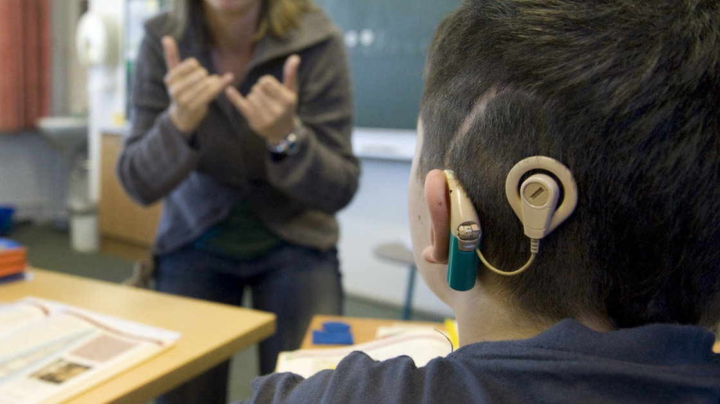

April 8, 2012.

(You can listen to the story below on http://www.npr.org/2012/04/08/150245885/cochlear-implants-redefine-what-it-means-to-be-deaf)

LAURA SULLIVAN, HOST:

It's WEEKENDS on ALL THINGS CONSIDERED from NPR News. I'm Laura Sullivan.

*A schoolboy with a cochlear implant listens to his teacher during lessons at a school for the hearing impaired in Germany.*

For more than a century, parents of deaf children had few options when it came to finding an education for their children. Most sent their kids to boarding schools for the deaf. Many of the children and the schools thrived in the shadows, embracing a distinct deaf culture.

But recent advances in medicine and technology are now reshaping what it means to be deaf in America. Children who could never hear a sound are now adults who can hear everything. And that is having a dramatic impact on the nation's historic deaf schools as well as on the lives of people like Shehzaad Zaman. Zaman was born deaf 31 years ago to a family where everyone else could hear. His parents were worried. They wanted him to fit into a hearing world.

SHEHZAAD ZAMAN: My parents wanted me to learn how to be able to listen and to be able to speak despite not being able to hear.

SULLIVAN: Zaman went to a special school for the deaf at first, but in third grade, his parents changed their mind. They sent him to therapy to teach him to read lips and then they moved him to his neighborhood school in Long Island, New York. He learned to play sports and make friends, but it was never easy.

ZAMAN: You know, all my peers were able to use the telephone and, you know, have conversations in noisy restaurants. And it was actually getting harder and harder for me to have a conversation outside of one-on-one or one-on-two.

SULLIVAN: But then the summer before his senior year, a small miracle happened. A new piece of technology, called a cochlear implant, was helping deaf people hear. Doctors surgically inserted one into his ear. He woke up and the world was an entirely new place.

ZAMAN: At that time, I didn't know what I was hearing. You know, I was hearing so many different things that sounded so mechanical. And I was hearing the air conditioner or running water or the bird chirping, and I didn't know what it was. So it really took some time for my brain to process. And I would have to sit in the backyard just to try to absorb all the sounds.

SULLIVAN: More than half of all deaf children are now getting cochlear implants, and every year, the number increases. One-in-four deaf adults also now have it, though it takes longer for adult brains to adapt to hearing sound. For Zaman, the decision to get an implant was practical as well as emotional. He wanted to go to med school, and he knew a doctor needed to hear.

ZAMAN: In medicine, it's not acceptable to be able to hear 70 percent of the information, because that can make a difference in terms of the quality of patient care. So I was always trying to, you know, get up to 100 percent accuracy in terms of understanding the information.

SULLIVAN: Today, he is a physician in Sacramento. And last year, he received a second cochlear implant in his other ear, which has brought his hearing to close to 100 percent. He says he no longer thinks about not being able to hear. Only in rare moments when there's a lot of noise does he search for someone's lips.

ZAMAN: You know, we live in a hearing world, in a hearing society, you know, so it's really important to be able to hear. And I was just happy because, you know, I would be able to have much more ease in terms of communicating with people.

SULLIVAN: Zaman is already on his fourth upgrade of the device. And Dr. John Niparko, an ear specialist at Johns Hopkins Hospital, says there will be many more in the years ahead.

DR. JOHN NIPARKO: Just like our cell phones, our laptops are getting smaller, faster, smarter, cochlear implants are becoming smarter in terms of bringing in the most important sound signals that are in the environment to the ear of the implant listener.

SULLIVAN: Experts say that while they know that one in 1,000 children are born genetically deaf every year, it's almost impossible to track the rate of deafness over time. Hearing impairment is a spectrum, and it changes.

So have its causes. Diseases like rubella, scarlet fever and measles that have caused hearing loss have all but been eradicated by vaccines. But more premature babies with hearing loss are surviving. There also appears to be more children with autism, which has been linked to hearing difficulties.

But what is certain is that more than half of the children who once were deaf, for whatever reason, can now hear. Dr. Niparko has performed hundreds of the surgeries.

NIPARKO: Well, the cochlear implants are remarkable technology that can take in sound waves much like a hearing aid would. But instead of simply amplifying those sound waves and delivering them to the eardrum, what the cochlear implant does is to take that energy and translate it into an electrical code. That code is sent along a series of contacts, which are placed directly next to the hearing nerve. And through microcurrent injections, through small packets of electricity, we can activate that hearing nerve, thus recreating the act of hearing.

SULLIVAN: And will that work for most deaf people?

NIPARKO: For the vast majority of deaf people, there is, in fact, a viable, vital hearing nerve that retains its responsiveness to this kind of stimulation.

SULLIVAN: If the majority of deaf cases can be treated by a cochlear implant, why doesn't everybody get one?

NIPARKO: There remains, unfortunately, a socioeconomic divide with respect to access to cochlear implantation.

SULLIVAN: How much does it cost to get one?

NIPARKO: The device itself is about $32,000. The hospital costs and surgery add another 10 to $12,000 on that.

SULLIVAN: So does insurance cover it?

NIPARKO: Insurance generally does cover it, although there are some - unfortunately some Medicaid programs now that have constrained access.

SULLIVAN: If parents have a child today that's born deaf, what can they expect in the years ahead? I mean, might their child become just fully integrated in mainstream society and, I mean, even be just taken for a hearing person?

NIPARKO: We fully expect that a child without other disabilities is, in fact, going to be fully mainstreamed within three to five years of receiving a cochlear implant.

SULLIVAN: Do you think that means that there will be a time in the future where deafness is a choice?

NIPARKO: Well, I think we're already there, Laura. As individuals have learned more and more about this technology, they have learned that it wasn't developed as a referendum on deaf culture. It is a natural outgrowth of the technology boom that we have seen in our society over the past 30 years.

But as technologies tend to evolve, cultures tend to evolve. And we may be seeing a new culture evolve that uses this technology but still has foundations in the deaf world.

SULLIVAN: That's Dr. John Niparko from Johns Hopkins Hospital. For everything this technology has done for deaf people, it has created an uncertain future for deaf schools across the country. Dr. Richard Miyamoto is a former board member of the Indiana School for the Deaf.

DR. RICHARD MIYAMOTO: Deaf kids have changed, so I think that schools are going to have to change.

SULLIVAN: More than 80 percent of children who are or were hearing impaired now attend their local schools. Just a couple decades ago, those kids attended deaf schools, because there weren't any other options.

MIYAMOTO: In the past, we really didn't have much to offer deaf children so they would automatically just be in the sign culture and would grow up that way. And that was comfortable for them. But when cochlear implants came along and there was something to be done for deaf children, many of them were successful. So they ended up living their lives in the hearing world rather than the deaf world.

SULLIVAN: Miyamoto says the drop in enrollment has led many deaf schools to rethink their mission.

MIYAMOTO: What deaf schools have done is brought in many more complex kids with multi-handicapping situations, which are probably not part of their usual student population.

SULLIVAN: It's critical, however, that deaf schools adjust, Miyamoto says, not disappear.

MIYAMOTO: Oh, I think there's clearly a place for the traditional deaf schools because not everyone does well with the current technology.

ED BOSSO: So this is like a fifth grade class. And let's just go in and take a look real quick at one.

SULLIVAN: Ed Bosso opens the door to fifth grade at the Kendall Demonstration Elementary School on the campus of Gallaudet University, the nation's premiere deaf college.

BOSSO: These tables are grouped in a semicircle right around the teacher's desk.

SULLIVAN: Bosso heads the elementary and high school here. The desks in this classroom all face each other with the teacher at the head. Bosso explains that this school is bilingual. It teaches in sign, but it also teaches English out loud. That's the way this school has always taught. But even he can sense change is coming. There are 265 students here.

How does that compare to decades past? More, less, about the same?

BOSSO: Oh, it's less. It's less. If you would look at the history of schools for the deaf, there was a point in time where these schools were burgeoning because of the rubella bulge. I mean, at that time, rubella caused deafness. We didn't know if the medications around it caused deafness. And so we had a huge group of students who were deaf because of that.

SULLIVAN: When was that?

BOSSO: It started in the '60s, into the '70s, '80s.

SULLIVAN: At one point, the school had more than 500 students.

BOSSO: So now we have here one first grade, one second grade, one third grade, one fourth grade. Back then, we probably had two first grades or three first grades, three second. So there were more peers.

SULLIVAN: Then in 1975, Congress passed the Education for All Handicapped Children Act. It mandated all schools accommodate children with disabilities.

BOSSO: The law said kids should be, to the maximum extent appropriate, be educated in their home school with non-disabled peers. So people start there. And what often happens is kids fail their way into the deaf school.

SULLIVAN: These days, the school has found a niche helping students adjust to their implants before they leave for a traditional school.

BOSSO: Even a kid who's born and gets implanted, until that implant starts working, until they can listen to learn, they have to learn to listen. So while they're learning to listen - learning to use their device, they're missing a lot.

SULLIVAN: The school is also now reaching out to children with multiple disabilities in addition to hearing loss. One of the more common is autism.

We are seeing students that have additional disabilities at our doorstep, and people need to know how to serve them. And so we're going to try and fill that gap and support people nationally on that.

If it sounds like Bosso is navigating the issue delicately, he is. It's a touchy subject for some at the school, breaking from decades of tradition and history. But the change has already come. This year, one-in-five students have a second separate disability in addition to not being able to hear.

**Part one: answer the following questions based on the interview above.**

1. **Explain** the main difference between a cochlear implant and a hearing aid. (2 marks)

(Minimum of two sentences).

_________________________________________________________________________________________________

_________________________________________________________________________________________________

_________________________________________________________________________________________________

_________________________________________________________________________________________________

_________________________________________________________________________________________________

_________________________________________________________________________________________________

_________________________________________________________________________________________________

3. **Explain** why not everyone is able to receive cochlear implants. (2 marks)

(Minimum of two sentences).

_________________________________________________________________________________________________

_________________________________________________________________________________________________

_________________________________________________________________________________________________

_________________________________________________________________________________________________

4. The Kendell Demonstration Elementary School is bilingual. **State** what this means. (1 mark)

_________________________________________________________________________________________________

_________________________________________________________________________________________________

5. The Kendell Demonstration Elementary School offers ASL. **State** what the abbreviation ASL stands for. (1 mark)

_________________________________________________________________________________________________

7. In 1975 the Education for All Handicapped Children Act was passed in the USA. **Describe** what this law meant. (Minimum of two sentences). (2 marks)

_________________________________________________________________________________________________

_________________________________________________________________________________________________

_________________________________________________________________________________________________

_________________________________________________________________________________________________

_________________________________________________________________________________________________

_________________________________________________________________________________________________

**Part two: how a cochlea implant works**

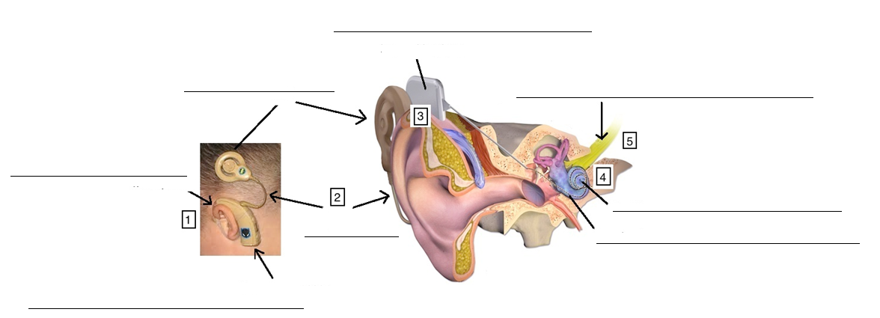1. The diagram below shows the cochlea implant fitted to a human ear. Label the parts. (8 marks)

2. Each number represents a step that occurs in the process of hearing using a cochlea implant.

Describe what is happening at each step. (Minimum 1 sentence for each step). (5 marks)

1. _______________________________________________________________________________________________

_________________________________________________________________________________________________

_________________________________________________________________________________________________

_________________________________________________________________________________________________

2. _______________________________________________________________________________________________

_________________________________________________________________________________________________

_________________________________________________________________________________________________

_________________________________________________________________________________________________

3. _______________________________________________________________________________________________

_________________________________________________________________________________________________

_________________________________________________________________________________________________

_________________________________________________________________________________________________

4. _______________________________________________________________________________________________

_________________________________________________________________________________________________

_________________________________________________________________________________________________

_________________________________________________________________________________________________

5. _______________________________________________________________________________________________

_________________________________________________________________________________________________

_________________________________________________________________________________________________

_________________________________________________________________________________________________

**Part three: answer the following questions using the internet or books as research.**

1. There are two general types of hearing loss; congenital or acquired. (1 mark)

a) **State** when an acquired hearing loss occur in a person.

_________________________________________________________________________________________________

b) **State** when a congenital hearing loss occur in a person. (1 mark)

_________________________________________________________________________________________________

2. **State** the name of the device or piece of equipment that is used to measure loudness. (1 mark)

_________________________________________________________________________________________________

3. **State** the unit of measurement that loudness is measured in. (Write the name and symbol). (1 mark)

_________________________________________________________________________________________________

4. **Explain** what hair cells are, where they are located and how they are damaged. (3 marks)

(Minimum of two sentences).

_________________________________________________________________________________________________

_________________________________________________________________________________________________

_________________________________________________________________________________________________

_________________________________________________________________________________________________

_________________________________________________________________________________________________

_________________________________________________________________________________________________

_________________________________________________________________________________________________

_________________________________________________________________________________________________

_________________________________________________________________________________________________

_________________________________________________________________________________________________

_________________________________________________________________________________________________

_________________________________________________________________________________________________

**Part four: history**

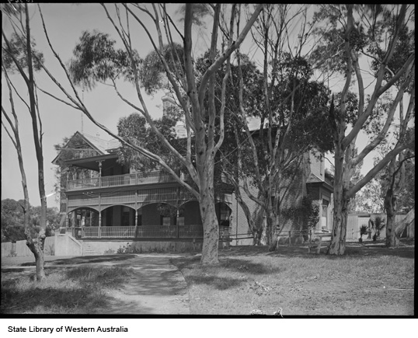1. The WA School for Deaf Children was established in East Perth and moved to Cottesloe in 1900. It was a residential school (boarding school) that admitted children of all ages.

a) What year was the school established? __________ (1 mark)

b) What year did the residential section of the school close?

_________ (1 mark)

2. Australia has a law (similar to the US Education for All Handicapped Children Act) called the Commonwealth Disability Discrimination Act. **State** what year was this law passed (put in place). (1 mark)

_________________________________________________________________________________________________

3. **Explain** the purpose of the Commonwealth Disability Discrimination Act. Explain what it means for mainstream schools and parents of children with disabilities. (Minimum of three sentences). (3 marks)

_________________________________________________________________________________________________

_________________________________________________________________________________________________

_________________________________________________________________________________________________

_________________________________________________________________________________________________

_________________________________________________________________________________________________

_________________________________________________________________________________________________

_________________________________________________________________________________________________

_________________________________________________________________________________________________

_________________________________________________________________________________________________

_________________________________________________________________________________________________

_________________________________________________________________________________________________

_________________________________________________________________________________________________

_________________________________________________________________________________________________

_________________________________________________________________________________________________

**How to reference**

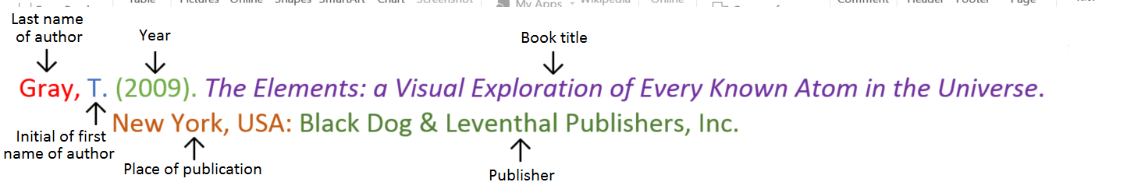**Book**

**Book with two authors**

Shermer, M., & Benjamin, A. (2006). *Secrets of Mental Math: The Mathemagician’s Guide to Lightning Calculation and Amazing Mental Math Tricks*. New York, USA: Three Rivers Press.

**Book with editor**

Kasdorf, W. E. (Ed). (2003). *The Columbia guide to digital publishing*. New York, USA: Columbia University Press.

**Book with different editions**

Nagle, G., & Cooke, B. (2012). *Geography Study Guide: Oxford Ib Diploma Programme* (2nd ed.). Oxford, UK: Oxford University Press.

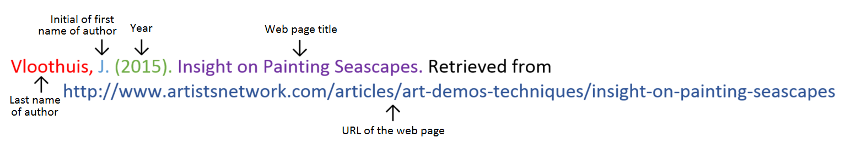**Website**

**Website with no author** (put title of page at the front)

Aranmore Catholic College. (2014). Retrieved from http://www.aranmore.wa.edu.au/

**Website with no date**

The Zadkine Museum. (n.d). Retrieved http://www.france.fr/en/museums/zadkine-museum.html

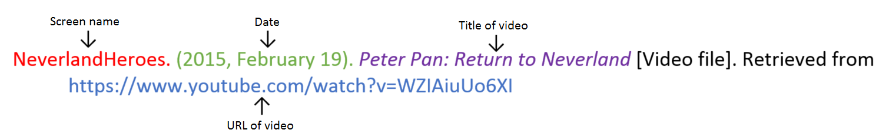**Video file**

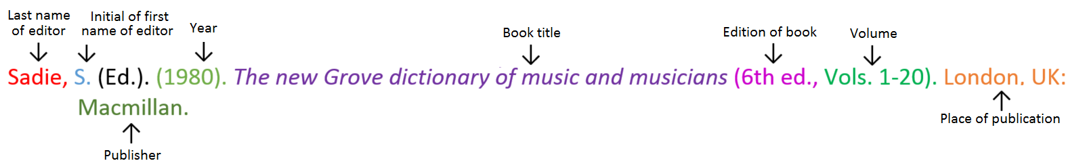**Encyclopaedia or dictionary**

**References:** minimum of two references, from two different types of sources.

_________________________________________________________________________________________________

_________________________________________________________________________________________________

_________________________________________________________________________________________________

_________________________________________________________________________________________________

_________________________________________________________________________________________________

_________________________________________________________________________________________________

_________________________________________________________________________________________________

_________________________________________________________________________________________________

_________________________________________________________________________________________________

_________________________________________________________________________________________________

_________________________________________________________________________________________________

_________________________________________________________________________________________________

_________________________________________________________________________________________________

_________________________________________________________________________________________________

_________________________________________________________________________________________________

_________________________________________________________________________________________________

_________________________________________________________________________________________________

|  |  |  |  |
| --- | --- | --- | --- |
| **Content** | **Description** |  | **Your**  **mark** |
| Research | Questions | 34 |  |
| Referencing | Minimum of 2 references  Minimum of 2 different type of sources used  Referenced in correct format | 1  1  1 |  |
| Presentation | Correct spelling  Correct grammar  Written neatly and clearly | 1  1  1 |  |
| **Total mark** | | 40 |  |

Mark as percentage %

Teacher comment:

_________________________________________________________________________________________________

_________________________________________________________________________________________________